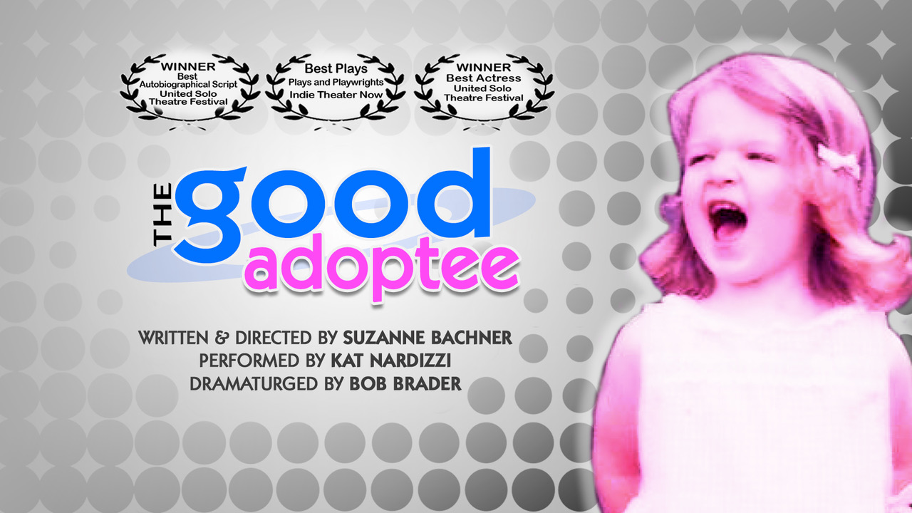

Table Of Contents
About • 3
Company • 4
Production Image • 8
Production History • 9
Press for The Good Adoptee • 16
Press for Suzanne Bachner • 20
Suzanne Bachner Interview • 21
Contact • 22

About


Can you imagine not knowing your own identity?
The Good Adoptee is the riveting and outrageous true story of award-winning playwright
Suzanne Bachner’s search for her first / birth parents in the face of New York State's sealed
records. Once she opens Pandora’s Box, can she find a way to integrate her dual identities and
still remain “the Good Adoptee”?

The Good Adoptee has won awards for Best Autobiographical Script and Best Actress for original star Anna Bridgforth when it premiered in the United Solo Theatre Festival in New York City. The show has toured to the London International Fringe Festival and all over the U.S., including a 7-week 9-city Connecticut tour to support the vital and now successful legislative efforts of Access Connecticut, to the 400-seat SJCC in Seattle and to global audiences in its virtual presentations including the 'r kids Fundraiser at The Shubert. The Good Adoptee recently made its triumphant return to live performance on stage at the CUB Retreat in Tampa, FL followed by a show and All-Star Panel event at The Kraine Theater in NYC.

The Good Adoptee
was awarded

Best Autobiographical Script – Suzanne Bachner
Best Actress – Anna Bridgforth
United Solo Theatre Festival
Best Plays – Indie Theater Now

Company

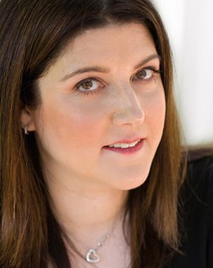
Suzanne Bachner • Playwright & Director
is an award-winning playwright and director and an adoptee rights advocate. Her play, CIRCLE, was called “ingenious” by The New York Times, ran for five months Off Broadway, was produced nationally, followed by a Sold Out International Tour where it was optioned for production in Australia and awarded Most Daring Show of the London Fringe. Playwriting and directing: her NYC cult hit, Icons & Outcasts which transferred to The Duplex for a six-month run; a five-month NYC run and international tour of her choose-your-own-adventure comedy, BITE; her 14-actor San Diego commission, the marriage equality epic, Brilliant Mistake, and her celebrated kaleidoscopic memoir play, We Call Her Benny, which Broadway World called “the future of theatre”. Solo show directing: Bob Brader’s trio of internationally acclaimed, multi-award-winning solo shows and Gloria Rosen’s award-winning Listen…Can You Hear Me Now? Suzanne’s own true story, The Good Adoptee, won the Best Autobiographical Script award at United Solo, has toured to the London International Fringe Festival and across the US including the 400-seat SJCC in Seattle, has been part of law and life-changing adoptee rights advocacy and enjoyed global audiences in its virtual presentations. Most recently, Suzanne’s new play, Conversations with My Divorce Attorney was presented as a unique virtual reading that ran on Broadway On Demand. Her plays have been seen at PS NBC@HERE, the National Arts Club, the Michael Weller Theatre, the Samuel French Short Play Festival, Pulse Ensemble Theatre, Zeitgeist Stage Company, Mercury Players Theatre and 20th Century Fox at the Coronet Theater in LA, among others. Other plays include Screwdrivers & Sunday Brunch, Alexandra Triptych, Don’t Let Destiny Push You Around, Jump Start, Alice Through the Looking Glass, Temptation, Sex Ed, Flirting with Reality, How Soon Is Now? and Twin Studies. Suzanne studied playwriting with Romulus Linney and Adrienne Kennedy and holds an MFA from the Actors Studio Drama School at the New School University. She is a four-time OOBR Award winner, Playwright-in-Residence Emeritus at The Actors Institute, Resident Artist Emeritus at Pulse Theatre and FRIGID New York, and a member of the United Solo Academy and the Dramatists Guild.
jmtctheatre.com • circletheplay.com • conversationswithmydivorceattorney.com

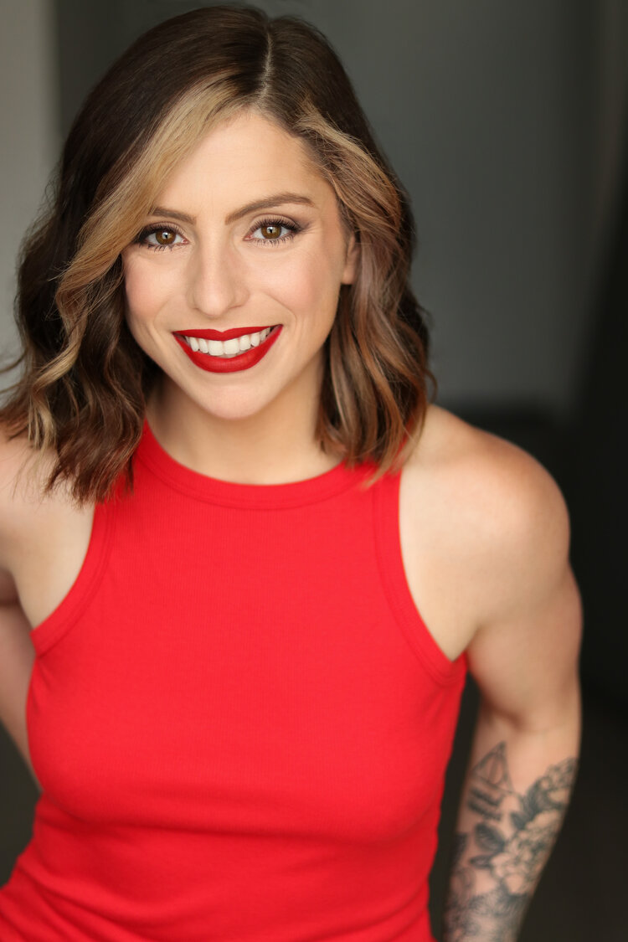
Kat Nardizzi • Performer
is an actor and singer living in NYC. Born in Los Angeles, she spent most of her childhood growing up in a handful of states across the south. Kat got her first taste of acting at the age of 5 when she was cast as Dot the Cow in The Little Red Hen and has loved performing ever since. During and after high school, she performed and interned with the Broadway Dreams Foundation helping organize and run week-long performing arts intensives across the country alongside Broadway professionals such as Gavin Creel, Eden Espinosa, Billy Porter, and Tituss Burgess. She received her BFA in Acting from Elon University and moved to NYC in 2013. Recently, she helped workshop Scott King & Mike Perrie Jr.’s new musical, Perfectly Imperfect. As an Artistic Associate of JMTC Theatre, Kat played in a trio of lead roles Suzanne Bachner’s plays: the sexy comedy CIRCLE at the APAP Conference, the virtual presentation of Birthday for the National Association for Adoptees & Parents and she workshopped and starred in the virtual reading of Conversations with My Divorce Attorney which premiered on Broadway On Demand. Other New York Theater includes The Wedding Party, Attempts On Her Life, and The Vagina Monologues. When not in rehearsal or performing, Kat loves to powerlift and make videos about queer dating and makeup on TikTok and Instagram (follow her on both: @katnardizzi).
katnardizzi.com

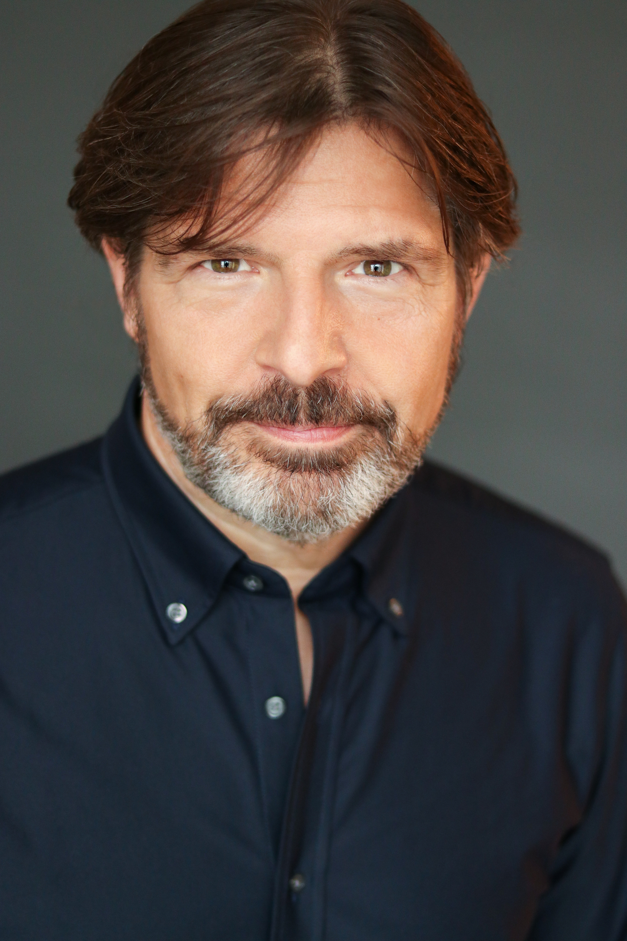
Bob Brader • Dramaturg
is an award-winning writer, actor, storyteller and monologist. Spitting In The Face Of The Devil, Bob’s acclaimed solo show, has toured all over the U.S. and Canada and won 7 Best of Awards including Best Show of the London Fringe and Best Script and Best Encore at the United Solo Theatre Festival. Bob’s new retelling of the story on the RISK! Podcast was called by RISK! creator and host Kevin Allison: "An absolute stunner. Bob Brader's story ‘Spitting in the Face Of The Devil’ is one of our best episodes ever." Bob made his international debut at the London Fringe Festival with his second solo show, Preparation Hex, a hemorrhoid tale and love story, which toured Canada and played in NYC at the Directors Company and the United Solo Festival. His new monologue, Smoker, had its world premiere on Theatre Row as part of United Solo, where it won the Best Autobiographical Show Award and went on to a highly acclaimed Canadian tour. Bob’s numerous acting credits include headlining the two-actor NYC run as well as the sold-out international tour of CIRCLE (Most Daring Show, London Fringe). He was in the original cast of We Call Her Benny and performed in both the recent tour and original five-month NYC run of BITE with JMTC Theatre, for which he is Executive Director. Other New York Theatre credits include Bryan Enk and Matt Gray’s supernatural theatrical serial, Penny Dreadful, at the Brick Theater (Teddy Roosevelt) and numerous DMTheatrics’ productions: Girls School Vampire, Bitch Macbeth, Who in the Hell is the Real Live Lorelei Lee? and Antony and Cleopatra (Caesar, OOBR Award). Film credits include Eat Me and DelanoCelli Productions’ award-winning Brooklyn in July. Bob trained with the Stella Adler Conservatory at the Tisch School of the Arts and is a member of the United Solo Academy, SAG-AFTRA and the Dramatists Guild.
bobbrader.com • spittinginthefaceofthedevil.com • smokertheplay.com

Katie Chai • Lighting & Sound Design
A stage manager and technician originally from Dallas, TX and a graduate of Marymount Manhattan College, Katie has worked with many companies in New York City, including American Globe Theatre, Horse Trade Theater Group, Playwright's Realm and others. She has also worked with the New York Musical Theatre Festival, NY Frigid Festival, the NYC Fringe Festival and five years with the United Solo Festival.
katiechai.webs.com

Chris Kateff • Projection Design
Chris is the Resident Projection Designer at JMTC Theatre. Virtual: Conversations with My Divorce Attorney, Smoker (JMTC Theatre); Betwixt & Between (Maggie Gallant Productions); Emma: a Pop Musical Stay at Home Version (Lafayette College). Off-Broadway: Hamlet, Medea (Titan Theatre Company), Off the Meter On the Record, Rebel in the Soul (Irish Repertory Theatre), Sheila's Day (Lincoln Center Institute); Rated P For Parenthood (Westside Theatre); The Road to Qatar (York Theatre); Wine Lovers (Triad Theater and international touring); Die Mommy Die (New World Stages). Off-Broadway associate design: Assassins (Classic Stage Company). Off-Broadway assistant design: Forever Dusty, Now. Here. This (Richard DiBella, designer). Broadway assistant design: Ring of Fire, Jersey Boys (Michael Clark, designer).
ckateff.wixsite.com/projections

Michael Koch • Graphic Design
is a freelance graphic designer and Resident Graphic Designer for JMTC Theatre. mkochgraphics.com
Shar Adrias • Video Production & Photography
is the owner and Creative Director of Movements by Shar. Shar established a film company in 2005.
Having been a dancer all her life and a choreographer, she brings a special kind of texture and vision to her projects. She operates on instinct and feeling, rather than math and science. Specializing in documentary and dance, her passion is in the art of story telling. "The world is so full of stories. I'd like to tell as many I can, for as long as I can.”
movementsbyshar.com

JMTC Theatre • Producer
is an award-winning, international, artist-driven theatre company committed to creating powerful, visceral, passionate theatrical experiences that are provocative and transformative. By partnering with national and international nonprofit organizations like Safe Horizon and You Gotta Believe, JMTC Theatre combines Art and Advocacy to raise both funds and awareness and invite engagement and social change. Founded in London in 1994 by Patrick Hillan, JMTC Theatre is based in NYC and has produced over 50 productions in New York City and collaborated with 100s of incredible theater artists. Past productions include Suzanne Bachner’s award-winning Off Broadway hit, CIRCLE; Thom Fudal’s daring production ofShakespeare’s Othello starring Patrick Hillan and Geoffrey Owens; Bob Brader’s acclaimed solo show, Spitting In The Face Of The Devil and Suzanne Bachner’s celebrated kaleidoscopic memoir play, We Call Her Benny. JMTC has presented work at PSNBC@HERE and 20th Century Fox at the Coronet Theater in LA, The Duplex, The National Arts Club, Flicks on 66 Wild West Digital Shootout (Finalist), the first-ever and 2nd annual FRIGID New York Festival, the Midtown International Theatre Festival (Best of the Fest) and the London International Fringe Festival, among many others. JMTC ran its own unique white box theater space in Chelsea for four years, is a Resident Company Emeritus at Pulse Theatre, The Actors Institute (now TAI Resources) and FRIGID New York, and has received four OOBR Awards, 14 Best in Fest Awards and Spirit of the Fringe from the London Fringe.
jmtctheatre.com • circletheplay.com • spittinginthefaceofthedevil.com • smokertheplay.com

Production Image

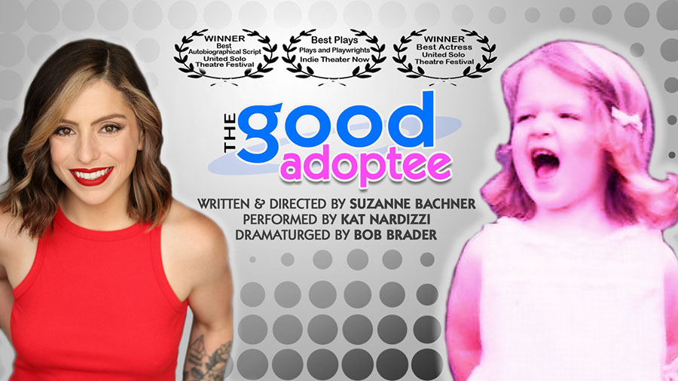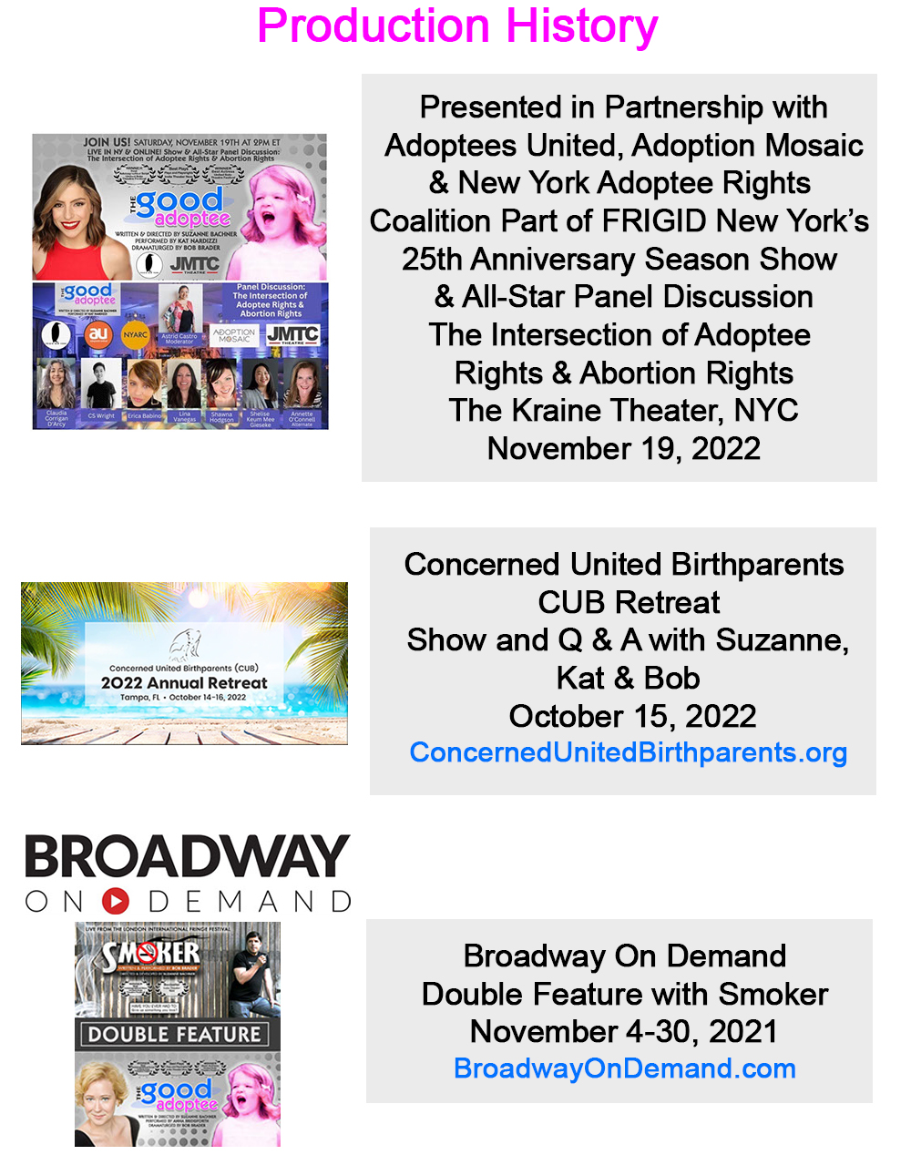
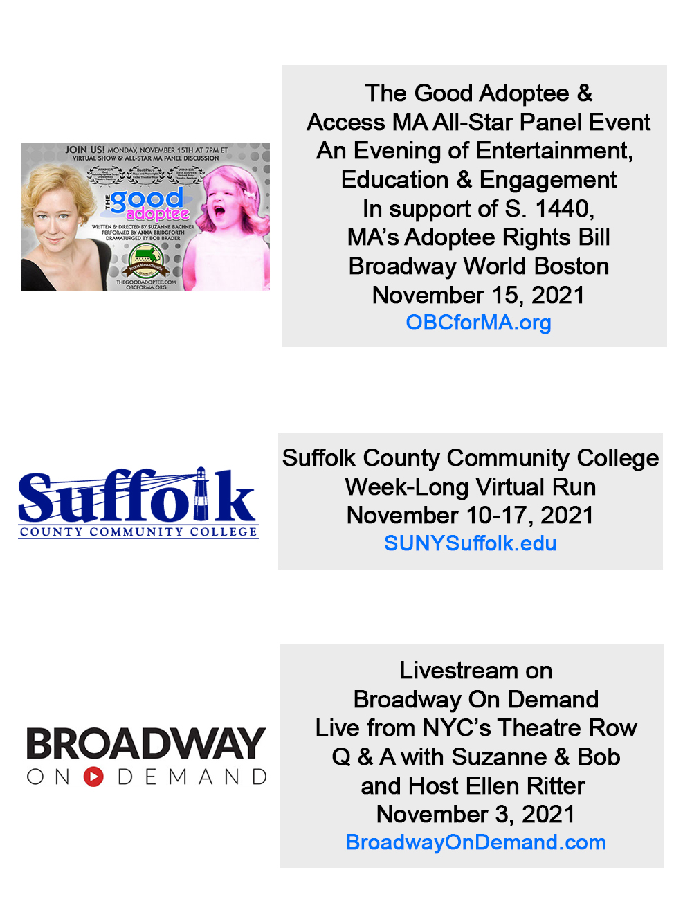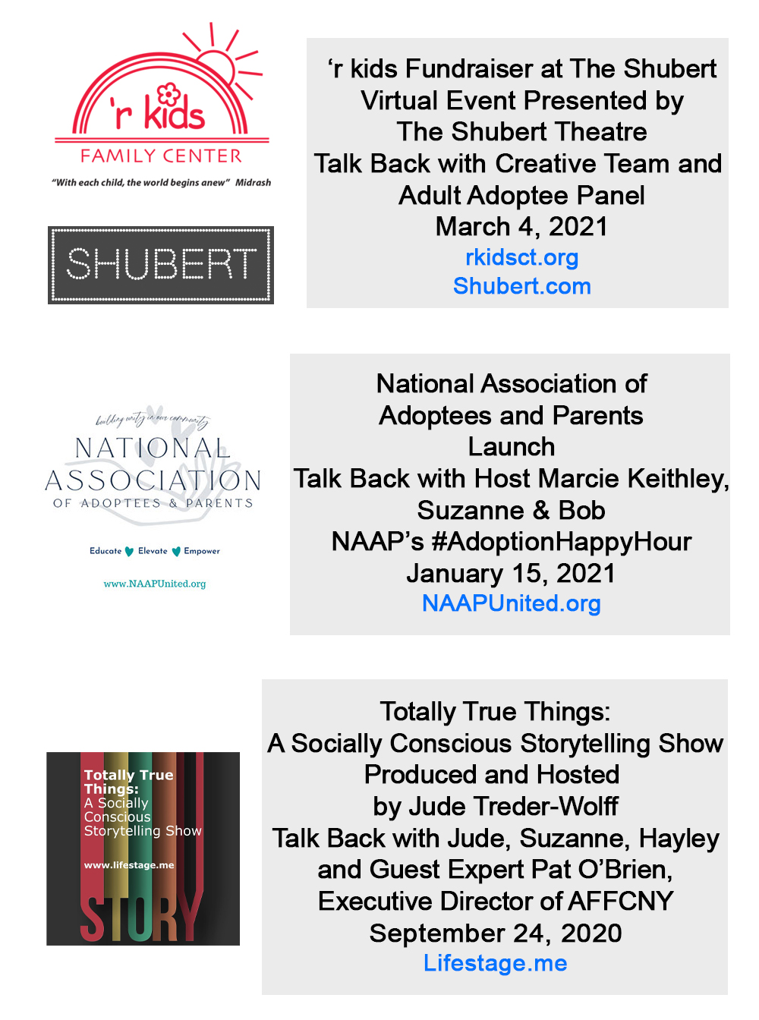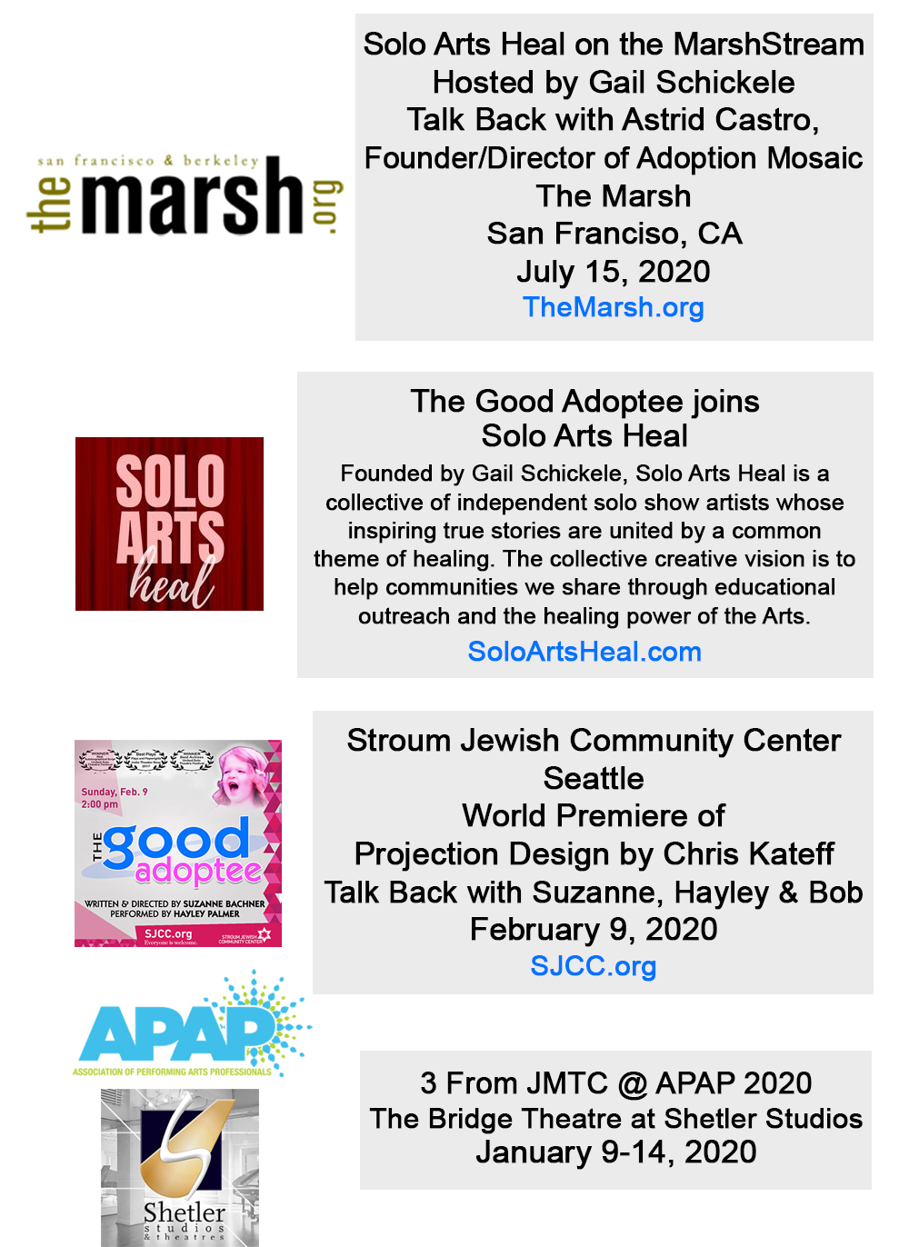
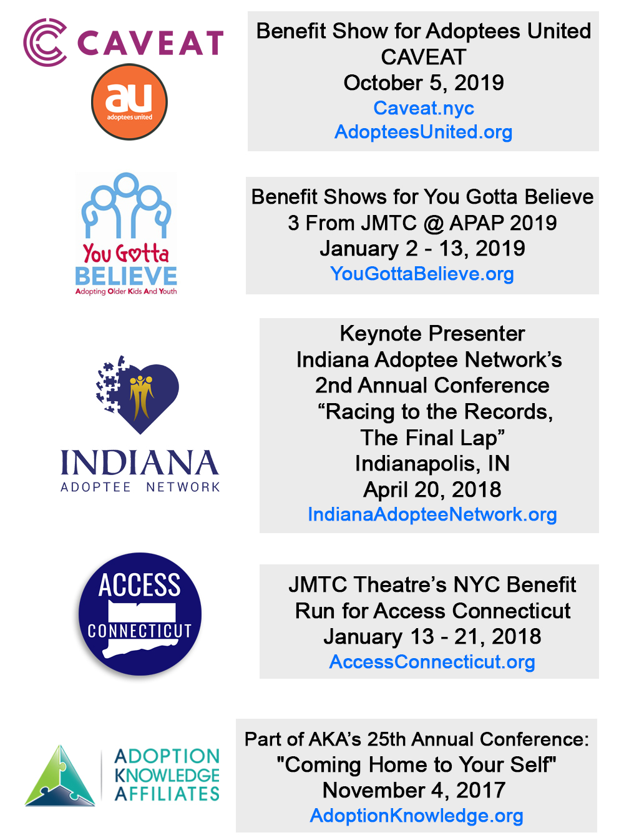
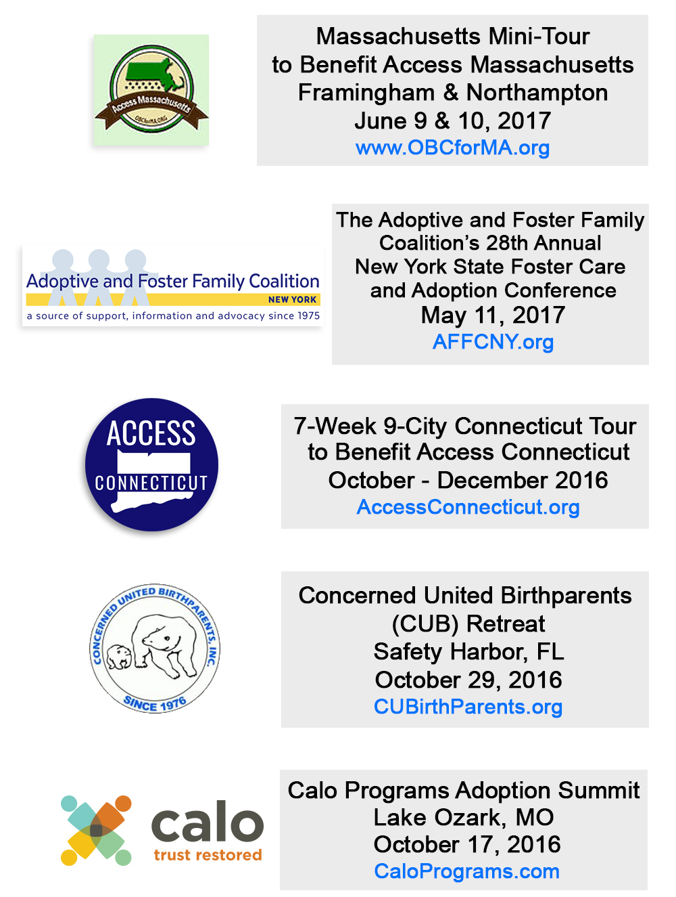
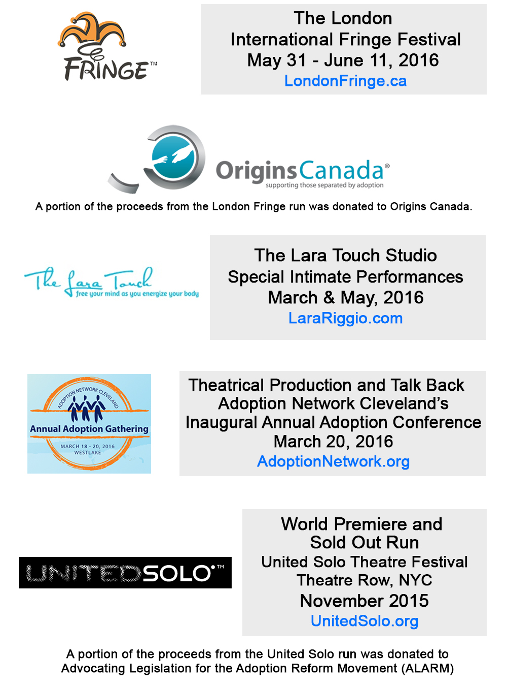
Press & Accolades for The Good Adoptee
★★★★★
"A story is rarely so personal and it has a very healthy amount of laugh-out-loud-humour!"
- Sadie takes the Stage, London UK

"Nardizzi delivers jokes and emotion with the same amount of mastery…. Bachner’s script took us to the point where we started to feel like we were right next to her heart."
- The Young-Howze Theatre Journal

“Brava to Suzanne Bachner and The Good Adoptee. Incredible Writing and Performance! A powerful show that the entire world needs to see!”
- Suz Bednarz, birthmother, writingmywrongs.com

"Superior writing…A spellbinding emotional detective story!"
- Darryl Reilly, Theater Scene

“The Good Adoptee is everything you want a solo show to be: well-crafted, lovingly performed and thoroughly entertaining!”
- Leslie Dileo, Hi Drama

“Yow! The Good Adoptee is utterly true, funny, sharp, smart, fearless, sad and crazy funny at the same time. The script is powerful!”
- Lorraine Dusky, Acclaimed Author, Birthmark & Hole in My Heart

“An exciting story that ultimately empowers an audience!”
- Martin Denton, NYTheater Now

“The story is moving and compelling with a rich, intelligent script!”
- Bob Criso, Hi Drama

“What a powerful piece of work. The script is tight and packed with emotion, the performance is brilliant and spot on. Perfection!”
- Betsie Norris, Executive Director, Adoption Network Cleveland

"It was AMAZING! Absolutely riveting and such an important play! I recommend it highly."
- Dr. Nancy L. Segal, Professor of Psychology and Director, Twin Studies Center, California State Univ., Fullerton; Author of Deliberately Divided: Inside the Controversial Study of Twins and Triplets Adopted Apart


The Good Adoptee

Anna Bridgforth is dynamic in playwright Suzanne Bachner’s spellbinding emotional detective story about a NYC woman searching for her birth parents.
I believe that everyone has the right to know his or her own identity, history, heritage and genealogy. I had to break all the rules to find mine and there are still missing pieces.
Evoking Nancy Drew, author Suzanne Bachner’s dramatized depiction of her own story spends several years attempting to find her birth parents in the course of her spellbinding autobiographical solo play, The Good Adoptee. Ms. Bachner’s superior writing is matched by actress Anna Bridgforth’s enthralling performance. Through her magnetism, charm and considerable acting skills, Ms. Bridgforth is dynamic on the contained and virtually bare stage for 80 minutes.
Nature verses nurture, loving one’s adoptive parents while still wanting to meet one’s birth parents and exploring the reasons for giving up a child are facets of the topic that Bachner skillfully explores with resonance.
Employing humor, documentary detail and suspense, Bachner offers an emotional detective story. Wit and whimsy meld with poignancy as the picaresque quest begins in present day New York City. It involves a gallery of characters, flashbacks. and often frustrating twists and turns, several of which are legal obstacles that impede such searches. Bureaucrats, a celebrated “adoption hunter,” the adopted parents and other key figures are all imaginatively incorporated into the narrative. Bridgforth is vocally and physically titanic as she switches back and forth between being Suzanne and playing the other characters with grandly distinctive characterizations.
Bachner’s direction has Bridgforth in a variety of precise and fluid positions that in concert with some simple clever visual flourishes make for an arresting presentation. There’s two large classic children’s ABC wooden blocks that get rearranged to connote different locations and that store a few instrumental props including an old-time Fisher Price chatter telephone. The symbolism of childhood is ever present throughout the adult situations. That’s particularly evident when Bridgforth wears closed-feet bunny rabbit pajamas during a wistful oration.
Red hues used for fantasy scenes are a neat feature of Katie Chai’s artfully stark lighting design. Ms. Chai’s sound design is equally as adept in realizing musical interludes and effects.
The Good Adoptee is an absorbing and theatrical take on its eternal subject matter.
This production is presented as part of “3 From JMTC.” JMTC Theatre is a company founded in 1994 that “combines art and advocacy to raise funds and awareness.” The Good Adoptee plays in repertory with two other solo shows, Smoker and Spitting in the Face of the Devil. The proceeds from this engagement go to You Gotta Believe, a foster youth organization and to the victim services agency Safe Horizon.

Suzanne Bachner's THE GOOD ADOPTEE at United Solo
by Martin Denton, Editor
United Solo, the world's largest festival dedicated to solo performance, is important for a lot of reasons. There's the sheer volume/excitement of it all--a showcase for brave and talented and eager solo theater practitioners from all over the world, dozens and dozens of them performing in the intimate Theater Row Studio space in Times Square, yielding a nonpareil immersive entertainment experience unlike any other, brining audiences face-to-face (and just feet or yards away) from actors and actor/writers and physical performers who are alone on stage with nothing but their own talent and the talents of their collaborators to carry them through an hour or an hour-and-a-half of raw and unfiltered theatricality.

And then there's the impulse that drives it all--the dire urgency of these artists to communicate something, to share something. United Solo is first and foremost a platform for the sharing of diverse, intense, necessary stories. (This is what binds United Solo to Indie Theater Now so intractably; and we're grateful and proud to be a partner of the festival since its inception in 2010, and to preserve many of the finest examples of the festival's efforts in script form online.)
Which brings me to The Good Adoptee, one of the hundred or so new solo plays premiering at United Solo this fall. It's written and staged by Suzanne Bachner, whose work as a playwright and director is well known to any aficionado of the NYC indie theater scene. It's dramaturged by Suzanne's husband and longtime collaborator Bob Brader, who is a solo performer of great skill and therefore knows a thing or two about how to make a successful one-person show. And it's performed by Anna Bridgforth, an actor of enormous intelligence and warmth and intensity, who brings Suzanne's own journey as (per the title) a "good adoptee" to life with energy, vivacity, and empathy. Indeed, all of these qualities spill over into the audience as we witness this 90-minute distillation of an aspect of Suzanne's experience that ultimately enlightens and enlarges us all.
The Good Adoptee is about Suzanne's search for her birth parents. It takes the shape of a classic mystery novel, with the playwright herself cast as the intrepid detective (she refers to herself as "Nancy Drew" on more than one occasion in the narrative); like the best examples of the form, it's filled with colorful characters (an enigma-dropping case-worker at the adoption agency; a P.I. with a reality show on the Oprah network), oodles of false starts and red herrings, a steadfast Dr. Watson-esque sidekick (husband/partner Bob), and--maybe a bit of spoiler here, sorry--a very satisfying conclusion.

What's most exciting to me about the play is how much it teaches a person like me--raised by both birth parents; no questions about his ancestry or origins--about the singular dilemma of the adoptee, who, like Suzanne, may grow up with this significant hole in her knowledge of who she actually is. I never thought about the gigantic barrier, for example, that a medical questionnaire could erect for someone in Suzanne's position: does anyone in my family have glaucoma, or breast cancer, or heart disease? Most of us know, but--due in part to a number of institutional edifices that seem mainly designed to protect the institutions themselves--Suzanne and other adoptees, good (or bad), cannot know.
And so, for 90 minutes we walk in Suzanne's shoes, and the lessons of that encounter illuminate a whole area of human experience for us. Talking about the thorny question of whether to even find out who her birth parents are, Suzanne notes that once we know something, we cannot un-know it. Which is why an event like The Good Adoptee matters so much: I was not only utterly immersed in an interesting and exciting story, but I left knowing something I didn't know before, and with an immediacy that makes me not just passively accept what I learned but want to delve further and discover more. The Good Adoptee--along with so many other works at United Solo--ultimately empowers an audience to set forth on further explorations of every corner of the human experience. Which is, I think, a grand mission indeed.


Hi! Drama

BOB CRISO REVIEWS
THE GOOD ADOPTEE
Written and Directed by Suzanne Bachner
Performed by Anna Bridgforth
United Solo Theater Festival
The psychological issues involved with an adoption are often poorly understood by the general public, state legislators, mental health professionals as well as those individuals directly involved in the adoption triangle itself — the birth parents, the adoptive parents and the adoptee. An individual’s right to know the truth about their origins has been under-appreciated and too-frequently undermined by ignorance and fear.
Suzanne Bachner has creatively addressed and articulated these issues through her own adoption experience in “The Good Adoptee,” recounting her personal story with all its confusion, conflicts and emotional ups and downs. The title,“The Good Adoptee,” refers to a term coined by author Betty Jean Lifton and refers to the anxious adoptees need to please in order to feel secure.
Suzanne always knew she was adopted but her emotional awakening begins when she was seeking her medical history. She also realized that her adoption experience did not jive with what she had learned from a professor in school: “Everything is genetically determined.” She begins an arduous and, at times, emotionally wrenching search and frames it as if it were a Nancy Drew mystery with gravitas while somehow managing to keep her sense of humor along the way. We meet a small cast of characters that includes a frustrating and officious adoption agency worker on one hand and her loyal and helpful husband on the other.
The story is moving and compelling and keeps us interested to the end. With a rich, intelligent script and a sensitive, spirited performance by Anna Bridgforth, one hopes this playwright and actress continue to find good material to display their talents.

Press and Awards for Suzanne Bachner
“Ingenious…it is no accident that so many of the sharp jokes come as complete surprises.”
- The New York Times (Circle)
"One of the most theatrically interesting pieces I have seen in years...The direction is startlingly crisp and clean...The writing is deft and fearless...This play should be seen by anyone wanting to know the future of theatre!"
- Broadway World (We Call Her Benny)
★★★★1/2
“A flawless show that will keep the audience engaged and laughing from start to finish.”
- The London Free Press (BITE)
★★★★
“The real star is Bachner’s script. This smart two-hander is sometimes laugh-out-loud funny, sometimes unsettling, but consistently thoughtful and surprising.”
- CBC Manitoba (Circle)
“Suzanne Bachner’s impressive Circle puts on display a writer with such a winning combination of humor and empathy…elegantly written and moving…Bachner hits her social targets with repeated accuracy.”
- BACK STAGE (Circle)

“Deft Theatrical Storytelling…Bachner’s writing is witty, knowing, compassionate.”
- New York Post (Circle)

"Bachner has a genius for dialogue...Her direction is exquisitely theatrical...amazing."
- Broadway World (Sex Ed)

“Bachner’s mastery is once again revealed as she imperceptibly erases the thin line between innocent rebellion and staggering cruelty.”
- Electronic Link (Sex Ed)

“Bachner etches her characters with distinctive, psychologically revealing language.”
- The Village VOICE (Don’t Let Destiny Push You Around)
"One of the Biggest Hits in Indie Theater History!"
- Martin Denton, NYTheater Now (Circle)

WINNER • Most Daring Show • Circle • The London Fringe
WINNER • Spirit of the Fringe • The London Fringe
WINNER • OOBR Award • Circle
WINNER • OOBR Award • Twin Studies
WINNER • OOBR Award • Don’t Let Destiny Push You Around
WINNER • OOBR Award • Producer
WINNER • Best in Fest • Sex Ed • Midtown International Theatre Festival
WINNER • Best in Fest • Icons & Outcasts • Midtown Int’l Theatre Festival
WINNER • Madeline Sadin Award
My new play, THE GOOD ADOPTEE, Performed by Anna Bridgforth at Theatre Row as part of the United Solo Theatre Festival
An Interview with Suzanne Bachner
Indie Theater Now asked Suzanne Bachner a few questions about this upcoming event.
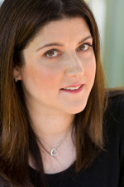
Who were the key figures who made this production happen—could be other artists, people who inspired the story, producers/producing company, etc.
Anna Bridgforth - the fierce, fearless, phenomenal actress with whom I have been lucky enough to work throughout the entire development of this project. Anna’s performance is magnificent and will knock your socks off. Bob Brader - my intrepid, insightful, inspiring dramaturg and partner. Not only did Bob live through the events of this play with me, but he has put up with me and been a beacon as I’ve been making this piece. Dr. Omar Sangare & Marcin Lipinski at United Solo who created a festival and space where unique adoptee stories can be told and who invited me to tell mine before I even knew I could.

Why is this a play, as opposed to a film or a web series or a novel (or anything else)? And what is it about live theater that attracts you most, that keeps you revved and jazzed to work in this form?
To me, there is no better place to tell the truth than live and in real time in front of an audience in the theater. Theater is unflinching and unforgiving - in the best possible way. When I decided I was ready to tell this part of my story, I wanted to do it in the most essential and powerful way possible - with a single incredible actress bringing it to life on stage.

Who taught you how to be a playwright? This could be specific teachers, or role models whose work you’ve seen or read, or of course any combination.
The late, great Romulus Linney taught me how to be a playwright - even though he didn’t believe it was something that could be taught. He gave out a one-page “textbook” on the first day of our workshop at the Actors Studio School of Drama at the New School listing 20 or so indispensable aspects of the craft and demonstrated to us that there was one item that had to be there or else nothing else mattered: blood and guts. Whenever I start getting too cute or too charming or avoiding the tough stuff, I can hear his voice and see the glint in his eye and it gets me back on course. I also had the great honor of studying one-on-one with another one of my theater heroes, the extraordinary Adrienne Kennedy. She got me started writing this incredibly personal piece when I had just begun searching. She kept saying: I think adoption is the key to this piece. She was right, of course.

What have you learned about this play as it has evolved from first draft to the present version? And what has surprised you in this current production-what did you discover in the work that you didn’t realize was there?
The first draft of this play was 7 hours long. Anna read it to me in rehearsal as I wrote it, and I read it to Bob in a single afternoon. I learned the difference between my story and this play. Once I realized that the focus of this play needed to be the search itself, which has its own dramatic motor, I was able to let it have the shape and form it needed. I later realized that lots of moments that I cut still ended up getting communicated in other moments of the play. The more I let go, the clearer the story became. The biggest surprise in rehearsal is that the play is funny - particularly as played by Anna. Her dozen characters are delicious. One woman’s tragedy is another’s comedy!

Without giving away any important surprises—what moment or moments do you most look forward to when you see this play being performed?
The first moment of the play is a HUGE surprise and I’m very much looking forward to seeing how the audience reacts. We’ve already surprised Bob and Katie Chai, our amazing Lighting Designer, with this, but I’m excited to see how a theater full of people respond together. Really I’m looking forward to sharing this play with an audience period - every single moment. Thrilled and completely freaked out in anticipation.
Contact
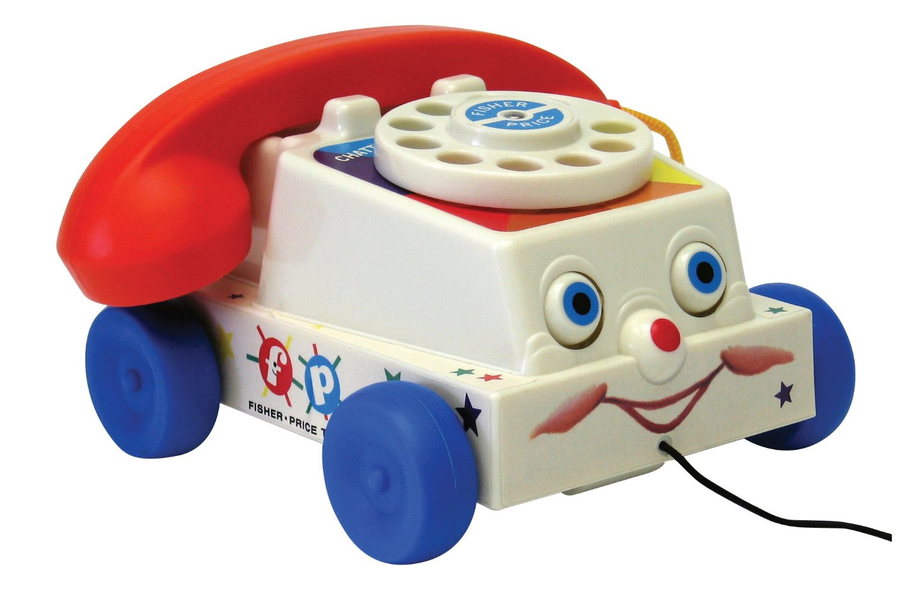
For booking requests or more information on
The Good Adoptee, please contact:
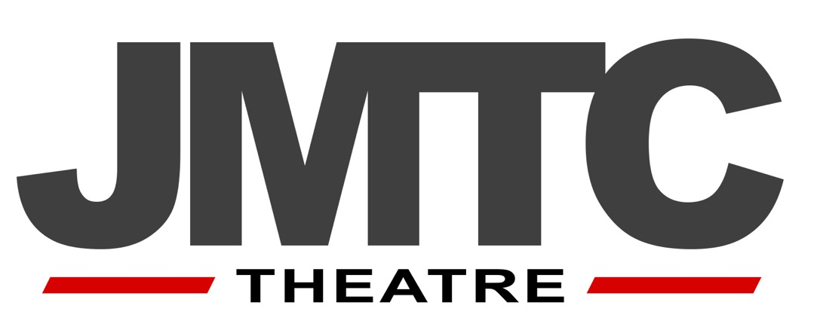
JMTC Theatre
200 West 54th Street, Suite 10L
New York, NY 10019
TheGoodAdoptee.com
Suzanne Bachner
Artistic Director
Suzanne@JMTCTheatre.com
917.783.5031
Bob Brader
Executive Director
Bob@JMTCTheatre.com
646.621.8252
